**VEHICLE RENTAL SYSTEM**

**Team Members:**

Hema Kothari

Mounika Donepudi

Rishikesh Reddy Maddi

**Fully Dressed Use Cases:**

1. Vehicle Rental Database

|  |  |
| --- | --- |
| Use Case Name | Vehicle Rental Database |
| Scope | Under Design |
| Level | User-Goal |
| Primary Actor | Database Administrator |
| Stakeholders and Interest | Professor and Database Administrator |
| Preconditions | Database software installed |
| Success Guarantee | Database is created and database administrator is able to maintain data |
| Main Success Scenario | 1. Create the database for vehicle rental |
| Extensions | Errors while creating database resolve those and re-create it |
| Special Requirements | NA |
| Technology and Data Variations List | Database |
| Frequency of Occurrence | Highly Used |
| Miscellaneous | NA |

Use Case Diagram: Vehicle Rental Database

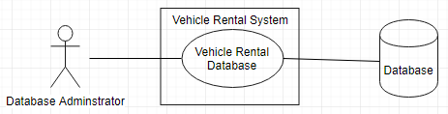

1. Upload Vehicle Data

|  |  |
| --- | --- |
| Use Case Name | Upload vehicle Data |
| Scope | Under Design |
| Level | Sub-function |
| Primary Actor | Administrator |
| Stakeholders and Interest | Professor and Administrator |
| Preconditions | Database is created, Application is up and running |
| Success Guarantee | Vehicle details are uploaded and saved to database |
| Main Success Scenario | 1. Admin visits the website 2. Select file with vehicle details to upload data in database |
| Extensions | Scenario 1:  1a) Refresh the website  Scenario 2:  2a) File format Not supported, system displays message of accepted file format  Scenario 3:  2a) File unreadable/Corrupt, system ask Customer to re-upload a valid file. |
| Special Requirements | Response time should be within seconds |
| Technology and Data Variations List | Browser, Database |
| Frequency of Occurrence | Highly Used |
| Miscellaneous | NA |

Use Case Diagram: Upload vehicle Data

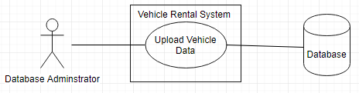

1. Search a Vehicle

|  |  |
| --- | --- |
| Use Case Name | Search a Vehicle |
| Scope | Under Design |
| Level | Sub-function |
| Primary Actor | Customer |
| Stakeholders and Interest | Professor and Customer |
| Preconditions | Application should be up and running |
| Success Guarantee | List of vehicle should be available to select |
| Main Success Scenario | 1. Customer visits the website 2. Customer Enters “Pick-up Date”, “Drop Off Date” and Location 3. Customers searches the vehicle |
| Extensions | Scenario 1:  1a) Customer refresh Page  Scenario 2:  2a) Customer can enter frequently travelled destination such as Disneyland.  Scenario 3:  2a) Location entered using voice recognition  Scenario 4:  2a) Location entered using Customer’s location. |
| Special Requirements | Response time should be within seconds |
| Technology and Data Variations List | Browser, Database |
| Frequency of Occurrence | 4 hits per second |
| Miscellaneous | NA |

Use Case Diagram: Search a Vehicle

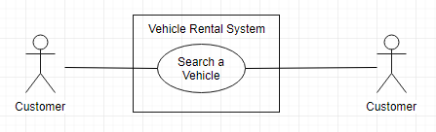

1. View Vehicle Details

|  |  |
| --- | --- |
| Use Case Name | View Vehicle Details |
| Scope | Under Design |
| Level | Sub-function |
| Primary Actor | Customer |
| Stakeholders and Interest | Professor and Customer |
| Preconditions | Customer Entered Search Criteria |
| Success Guarantee | List of vehicle displayed should have details of Make and Model, Image, Price and Mileage |
| Main Success Scenario | 1. Customers searches a vehicle 2. Details of vehicles Make and Model, Image, Price and Mileage is displayed |
| Extensions | Scenario 1:  2a) Customer refresh Page |
| Special Requirements | Response time should be within seconds |
| Technology and Data Variations List | Browser, Database |
| Frequency of Occurrence | 4 hits per second |
| Miscellaneous | NA |

Use Case Diagram: View Vehicle Details

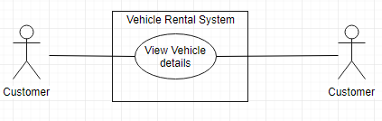

1. Search on Passenger Capacity

|  |  |
| --- | --- |
| Use Case Name | Search on Passenger Capacity |
| Scope | Under Design |
| Level | Sub-function |
| Primary Actor | Customer |
| Stakeholders and Interest | Professor and Customer |
| Preconditions | Application should be up and running |
| Success Guarantee | List of vehicle displayed with defined passenger capacity |
| Main Success Scenario | 1. Customer visits the website 2. Customer Enters “Pick-up Date”, “Drop Date”, Location 3. Customer Enter Passenger Capacity 4. Customers searches the vehicle |
| Extensions | Scenario 1:  2a) Refer Use Case 3  Scenario 2:  3a) Customer re-enter Passenger Capacity |
| Special Requirements | Response time should be within seconds |
| Technology and Data Variations List | Browser, Database |
| Frequency of Occurrence | 4 hits per second |
| Miscellaneous | NA |

Use Case Diagram: Search on Passenger Capacity

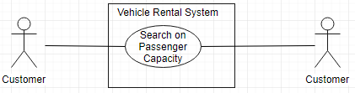

1. Search on Price Range

|  |  |
| --- | --- |
| Use Case Name | Search on Price Range |
| Scope | Under Design |
| Level | Sub-function |
| Primary Actor | Customer |
| Stakeholders and Interest | Professor and Customer |
| Preconditions | Application should be up and running |
| Success Guarantee | List of vehicle displayed within the price range |
| Main Success Scenario | 1. Customer visits the website 2. Customer Enters “Pick-up Date”, “Drop Date”, Location 3. Customer Enters Price Range 4. Customers searches the vehicle |
| Extensions | Scenario 1:  2a) Refer Use Case 3  Scenario 2:  3a) Customer re-enter Price Range |
| Special Requirements | Response time should be within seconds |
| Technology and Data Variations List | Browser, Database |
| Frequency of Occurrence | 4 hits per second |
| Miscellaneous | NA |

Use Case diagram: Search on Price Range

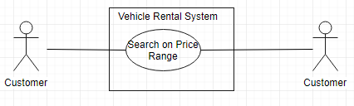

1. Search on Vehicle Type

|  |  |
| --- | --- |
| Use Case Name | Search on Vehicle Type |
| Scope | Under Design |
| Level | Sub-function |
| Primary Actor | Customer |
| Stakeholders and Interest | Professor and Customer |
| Preconditions | Application should be up and running |
| Success Guarantee | List of vehicle displayed for given vehicle type |
| Main Success Scenario | 1. Customer visits the website 2. Customer Enters “Pick-up Date”, “Drop Date”, Location 3. Customer Enters Vehicle Type 4. Customers searches the vehicle |
| Extensions | Scenario 1:  2a) Refer Use Case 3  Scenario 2:  3a) Customer re-enter Vehicle Type |
| Special Requirements | Response time should be within seconds |
| Technology and Data Variations List | Browser, Database |
| Frequency of Occurrence | 4 hits per second |
| Miscellaneous | NA |

Use Case Diagram: Vehicle Type

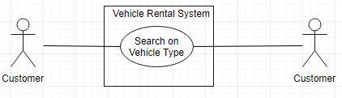

1. Search on Transmission Mode

|  |  |
| --- | --- |
| Use Case Name | Search on Transmission Mode |
| Scope | Under Design |
| Level | Sub-function |
| Primary Actor | Customer |
| Stakeholders and Interest | Professor and Customer |
| Preconditions | Application should be up and running |
| Success Guarantee | List of vehicle displayed for given transmission mode |
| Main Success Scenario | 1. Customer visits the website 2. Customer Enters “Pick-up Date”, “Drop Date”, Location 3. Customer Enters Transmission Mode 4. Customers searches the vehicle |
| Extensions | Scenario 1:  2a) Refer Use Case 3  Scenario 2:  3a) Customer re-enter Transmission Mode |
| Special Requirements | Response time should be within seconds |
| Technology and Data Variations List | Browser, Database |
| Frequency of Occurrence | 4 hits per second |
| Miscellaneous | NA |

Use Case Diagram: Search on Transmission Mode

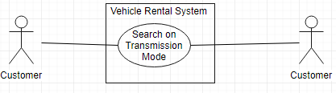

1. Register an Account

|  |  |
| --- | --- |
| Use Case Name | Register an Account |
| Scope | Under Design |
| Level | Sub-function |
| Primary Actor | Customer |
| Stakeholders and Interest | Professor and Customer |
| Preconditions | Application should be up and running |
| Success Guarantee | Registered an Account |
| Main Success Scenario | 1. Customer enters username, password, First Name, Last Name, Email and DOB (Mandatory) 2. System stores Customer information and creates an account |
| Extensions | Scenario 1:  1a)Username already exists and system displays available username  1b) Customer enters new or choose from available username  Scenario 2:  1a) All fields not entered, system displays message to enter all fields  1b) Customer enters all fields value  Scenario 3:  1a) Incorrect format entered for given fields e.g. email in wrong format, system displays message to enter in correct format  1b) Customer enters correct details  Scenario 4:  2a) System unable to store details, message is displayed to re-enter details  2b) Customer re-enters details |
| Special Requirements | Response time should be within seconds |
| Technology and Data Variations List | Browser, Database |
| Frequency of Occurrence | Could be nearly continuous |
| Miscellaneous | NA |

Use Case Diagram: Register an Account

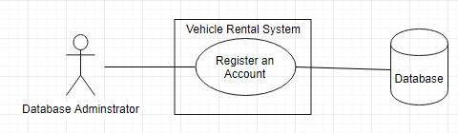

1. Login to Account

|  |  |
| --- | --- |
| Use Case Name | Login to Account |
| Scope | Under Design |
| Level | Sub-function |
| Primary Actor | Customer |
| Stakeholders and Interest | Professor and Customer |
| Preconditions | Customer should be registered |
| Success Guarantee | Logged in to application |
| Main Success Scenario | 1. Customer enters valid username and password 2. Customer logged in to account |
| Extensions | Scenario 1:  1a)Username or password invalid, systems displays message and displays screen to re-enter details  1b) Customer enters valid username and password  Scenario 2:  1a) Username, password not entered, system displays message to enter username and password  1b) Customer enters username and password |
| Special Requirements | Response time should be within seconds |
| Technology and Data Variations List | Browser, Database |
| Frequency of Occurrence | Could be nearly continuous |
| Miscellaneous | NA |

Use Case Diagram: Login to account

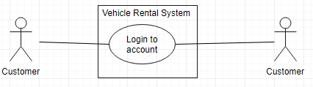

1. View the bookings

|  |  |
| --- | --- |
| Use Case Name | View the bookings |
| Scope | Under Design |
| Level | Sub-function |
| Primary Actor | Customer |
| Stakeholders and Interest | Professor and Customer |
| Preconditions | Customer logged in to the account |
| Success Guarantee | View all the bookings made |
| Main Success Scenario | 1. Customer selects view Bookings 2. All bookings made by the customer is displayed. |
| Extensions | Scenario 1:  2a) Customer refresh the page if bookings not displayed |
| Special Requirements | Response time should be within seconds |
| Technology and Data Variations List | Browser, Database |
| Frequency of Occurrence | Could be nearly continuous |
| Miscellaneous | NA |

Use Case Diagram: View the bookings

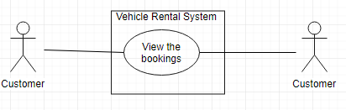

1. Filter on Average Customer Rating

|  |  |
| --- | --- |
| Use Case Name | Filter on Average Customer Rating |
| Scope | Under Design |
| Level | Sub-function |
| Primary Actor | Customer |
| Stakeholders and Interest | Professor and Customer |
| Preconditions | Customer searched vehicle and list of all the vehicles is displayed |
| Success Guarantee | List of all the vehicles displayed is sorted based on average Customer Rating |
| Main Success Scenario | 1. Customer clicks on average customer rating filter and list is sorted with it where 5 star being first |
| Extensions | Scenario 1:  1a) Customer re-click average customer rating filter if list is not sorted. |
| Special Requirements | Response time should be within seconds |
| Technology and Data Variations List | Browser, Database |
| Frequency of Occurrence | Could be nearly continuous |
| Miscellaneous | NA |

Use Case Diagram: Filter on Average Customer Rating

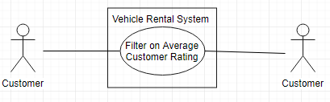

1. Filter on Price Range

|  |  |
| --- | --- |
| Use Case Name | Filter on Price Range |
| Scope | Under Design |
| Level | Sub-function |
| Primary Actor | Customer |
| Stakeholders and Interest | Professor and Customer |
| Preconditions | Customer searched vehicle and list of all the vehicles is displayed |
| Success Guarantee | List of all the vehicles displayed is sorted based on Price |
| Main Success Scenario | 1. Customer clicks on Price Range filter and list is sorted with Price |
| Extensions | Scenario 1:  1a) Customer re-click Price filter if list is not sorted. |
| Special Requirements | Response time should be within seconds |
| Technology and Data Variations List | Browser, Database |
| Frequency of Occurrence | Could be nearly continuous |
| Miscellaneous | NA |

Use Case Diagram: Filter on Price Range

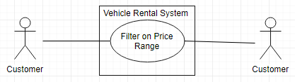

1. Vehicle Pick-up Locations

|  |  |
| --- | --- |
| Use Case Name | Vehicle Pick up location |
| Scope | Under Design |
| Level | Sub-function |
| Primary Actor | Customer |
| Stakeholders and Interest | Professor and Customer |
| Preconditions | Customer selected a Vehicle |
| Success Guarantee | All the pickup locations of the vehicle are displayed |
| Main Success Scenario | 1. System displays all the pick-up points at that location |
| Extensions | Scenario 1:  1a) Refresh the page if Pick-up location not displayed. |
| Special Requirements | Response time should be within seconds |
| Technology and Data Variations List | Browser, Database |
| Frequency of Occurrence | Could be nearly continuous |
| Miscellaneous | NA |

Use Case Diagram: Vehicle Pick-up Location

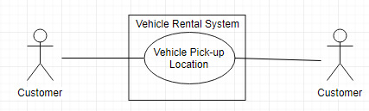

1. Drop Vehicle at Home

|  |  |
| --- | --- |
| Use Case Name | Drop Vehicle at Home |
| Scope | Under Design |
| Level | Sub-function |
| Primary Actor | Customer |
| Stakeholders and Interest | Professor and Customer |
| Preconditions | Customer completes booking the rented vehicle |
| Success Guarantee | Customer entered drop off and Pick-up location to send the vehicle to after booking |
| Main Success Scenario | 1. Customer select Drop Vehicle at Home Option 2. Customer enters the location to drop off and pick-up the booked vehicle so that company will send it to that location. |
| Extensions | Scenario 1:  2a) Location not entered then ask Customer to select from a pick-up location |
| Special Requirements | Response time should be within seconds |
| Technology and Data Variations List | Browser, Database |
| Frequency of Occurrence | Could be nearly continuous |
| Miscellaneous | NA |

Use Case Diagram: Drop Vehicle at Home

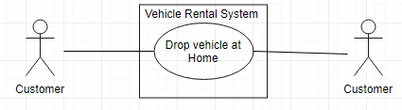

1. Billing for Vehicle Booking

|  |  |
| --- | --- |
| Use Case Name | Billing for Vehicle Booking |
| Scope | Under Design |
| Level | Sub-function |
| Primary Actor | Customer |
| Stakeholders and Interest | Professor and Customer |
| Preconditions | Customer selects the vehicle |
| Success Guarantee | Customer completed the payment and booked the vehicle |
| Main Success Scenario | 1. Customer select vehicle to be rented and go to billing 2. Customer select Billing method as Cash. 3. Pays the amount and book the vehicle |
| Extensions | Scenario 1:  2a) Billing method selected is Cards  2b) Complete payment authorization for card  Scenario 2:  Scenario 1:  2a) Billing method selected is Direct Deposit  2b) Enter Direct Deposit details and complete payment  Scenario 3:  2a) Billing method selected is Android/Apple Pay  2b) Complete Payment details  Scenario 4:  2a) Billing method selected is Cashier’s Check  2b) Upload Cashier’s Check and complete the billing  Scenario 5:  2a) Use the collected reward points and complete payment |
| Special Requirements | Response time should be within seconds |
| Technology and Data Variations List | Browser, Database |
| Frequency of Occurrence | Could be nearly continuous |
| Miscellaneous | NA |

Use Case Diagram: Billing for vehicle booking

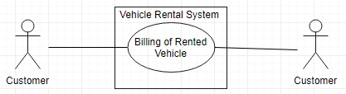

17. Receipt of booked Vehicle

|  |  |
| --- | --- |
| Use Case Name | Receipt of a booked Vehicle |
| Scope | Under Design |
| Level | Sub function |
| Primary Actor | Customer |
| Stakeholders and Interest | Professor and Customer |
| Preconditions | Vehicle should be rented |
| Success Guarantee | Receipt is generated |
| Main Success Scenario | 1. System presents receipt 2. Customer receives a receipt |
| Extensions | Scenario 1:  2a) Customer has to retry |
| Special Requirements | Response time should be within seconds |
| Technology and Data Variations List | Browser, Database |
| Frequency of Occurrence | Could be nearly continuous |
| Miscellaneous | N/A |

Use Case Diagram: Receipt of booked vehicle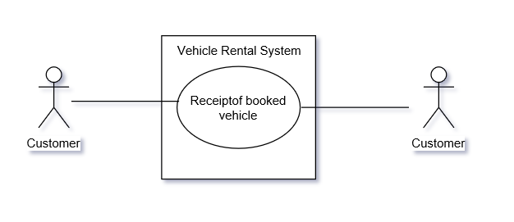

1. Adding Additional Drivers with insurance

|  |  |
| --- | --- |
| Use Case Name | Adding additional drivers |
| Scope | Under Design |
| Level | Sub function |
| Primary Actor | Customer |
| Stakeholders and Interest | Professor and Customer |
| Preconditions | Should have Primary driver and vehicle should be rented |
| Success Guarantee | Adds additional driver |
| Main Success Scenario | 1. Customer booked vehicle becomes a primary driver  2. Customer adds additional driver  3. Customer includes insurance of additional driver details |
| Extensions | Scenario 1:  2a) Customer has to retry adding additional drivers details and insurance |
| Special Requirements | Response time should be within seconds |
| Technology and Data Variations List | Browser, Database |
| Frequency of Occurrence | Could be nearly continuous |
| Miscellaneous | N/A |

Use Case Diagram: Adding additional drivers with insurance

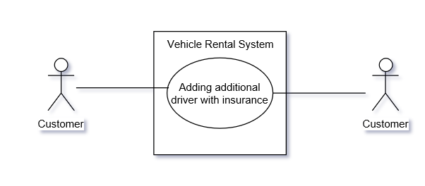

1. Printing receipt of booked vehicle

|  |  |
| --- | --- |
| Use Case Name | Printing receipt |
| Scope | Under Design |
| Level | Sub function |
| Primary Actor | Customer |
| Stakeholders and Interest | Professor and Customer |
| Preconditions | Vehicle should be rented |
| Success Guarantee | Receipt is printed |
| Main Success Scenario | 1. System presents receipt 2. Customer receives a receipt 3. Customer prints a receipt |
| Extensions | Scenario 1:  2a) Customer has to retry  Scenario 2:  3a) Customer has to re-print |
| Special Requirements | Response time should be within seconds |
| Technology and Data Variations List | Browser, Database |
| Frequency of Occurrence | Could be nearly continuous |
| Miscellaneous | N/A |

Use Case Diagram: Printing receipt of booked vehicle

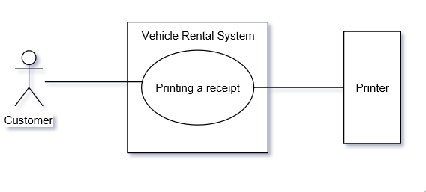

1. Upgrade an existing booking

|  |  |
| --- | --- |
| Use Case Name | Upgrade an Existing booking |
| Scope | Under Design |
| Level | Sub function |
| Primary Actor | Customer |
| Stakeholders and Interest | Professor and Customer |
| Preconditions | Vehicle should be rented |
| Success Guarantee | Upgraded booking |
| Main Success Scenario | 1. Customer retrieves his booking 2. Customer selects an upgraded vehicle. 3. Customer booked an upgraded vehicle and updated in the database |
| Extensions | Scenario 1:  1a) Customer have to re-try to retrieve his booking  Scenario 2:  2a) If vehicle is not upgraded, Customer has to re-select the upgraded vehicle |
| Special Requirements | Response time should be within seconds |
| Technology and Data Variations List | Browser, Database |
| Frequency of Occurrence | Could be nearly continuous |
| Miscellaneous | N/A |

Use Case Diagram: Upgrade an existing booking

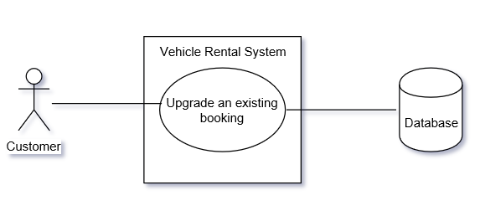

1. Assign privileges to Customer

|  |  |
| --- | --- |
| Use Case Name | Assign privileges to Customer |
| Scope | Under Design |
| Level | Sub function |
| Primary Actor | Administrator |
| Stakeholders and Interest | Professor and Administrator |
| Preconditions | Customer should be a member |
| Success Guarantee | Customer can view their bookings |
| Main Success Scenario | 1. Administrator should assign privileges to customer to view all his bookings 2. Customer views his bookings |
| Extensions | Scenario 1:  2a) Customer has to refresh the page to view his bookings |
| Special Requirements | Response time should be within seconds |
| Technology and Data Variations List | Browser, Database |
| Frequency of Occurrence | Could be nearly continuous |
| Miscellaneous | N/A |

Use Case Diagram: Assign privileges to customer

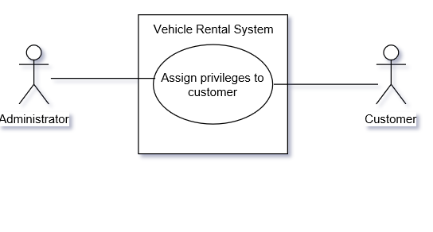

1. Search vehicle with voice recognition

|  |  |
| --- | --- |
| Use Case Name | Search vehicle with voice recognition |
| Scope | Under Design |
| Level | Sub function |
| Primary Actor | Customer |
| Stakeholders and Interest | Professor and Customer |
| Preconditions | Application should be up and running |
| Success Guarantee | List of vehicles should be available to select |
| Main Success Scenario | 1. Customer visits the website 2. Customer selects voice recognition option 3. Customer speaks to search a vehicle |
| Extensions | Scenario 1:  1a) Customer refresh Page  Scenario 2:  3a)Customer has to type to search for a vehicle |
| Special Requirements | Response time should be within seconds |
| Technology and Data Variations List | Browser, Database |
| Frequency of Occurrence | Could be nearly continuous |
| Miscellaneous | N/A |

Use Case Diagram: Search vehicle with voice recognition

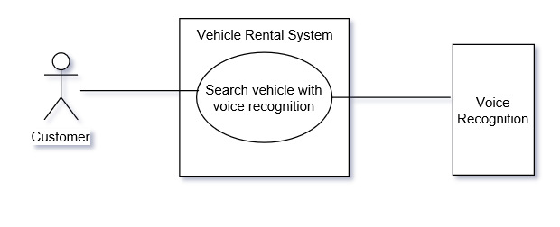

1. Modify future booking

|  |  |
| --- | --- |
| Use Case Name | Modify future booking |
| Scope | Under Design |
| Level | Sub function |
| Primary Actor | Customer |
| Stakeholders and Interest | Professor and Customer |
| Preconditions | Vehicle should be rented and have confirmation number |
| Success Guarantee | Modify booking |
| Main Success Scenario | 1. Customer retrieves his booking 2. Customer modifies his booking. 3. Modified booking is saved and updated to database |
| Extensions | Scenario 1:  1a) Customer re-tries to retrieve his booking  Scenario 2:  2a) Customer re-enters the modified booking details |
| Special Requirements | Response time should be within seconds |
| Technology and Data Variations List | Browser, Database |
| Frequency of Occurrence | Could be nearly continuous |
| Miscellaneous | N/A |

Use Case Diagram: Modify future booking

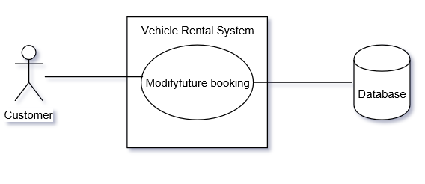

1. Cancel future booking

|  |  |
| --- | --- |
| Use Case Name | Cancel future booking |
| Scope | Under Design |
| Level | Sub function |
| Primary Actor | Customer |
| Stakeholders and Interest | Professor and Customer |
| Preconditions | Vehicle should be rented and have confirmation number |
| Success Guarantee | Cancel booking |
| Main Success Scenario | 1. Customer retrieves his booking. 2. Customer can cancel his booking. 3. Cancelled booking is saved and updated to database |
| Extensions | Scenario 1:  1a) Customer re-tries to retrieve his booking  Scenario 2:  2a) customer should try to re- cancel the booking |
| Special Requirements | Response time should be within seconds |
| Technology and Data Variations List | Browser, Database |
| Frequency of Occurrence | Could be nearly continuous |
| Miscellaneous | N/A |

Use Case Diagram: Cancel future booking

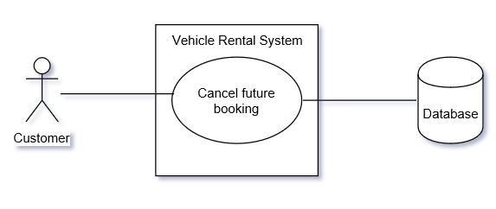

1. Provide Insurance details

|  |  |
| --- | --- |
| Use Case Name | Provide Insurance details |
| Scope | Under Design |
| Level | Sub function |
| Primary Actor | Customer |
| Stakeholders and Interest | Professor and Customer |
| Preconditions | Customer should have a booking |
| Success Guarantee | Insurance can be waived to rent a vehicle |
| Main Success Scenario | 1. Customer provides insurance details 2. Insurance is waived off |
| Extensions | Scenario 1:  1a) Company provides insurance |
| Special Requirements | Response time should be within seconds |
| Technology and Data Variations List | Browser, Database |
| Frequency of Occurrence | Could be nearly continuous |
| Miscellaneous | N/A |

Use Case Diagram: Providing Insurance details

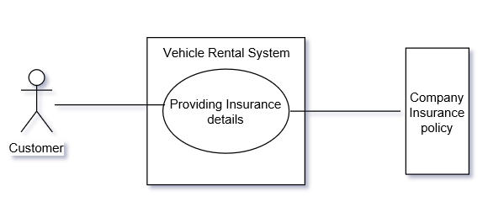

1. View Terms and Conditions

|  |  |
| --- | --- |
| Use Case Name | View Terms and conditions |
| Scope | Under Design |
| Level | Sub function |
| Primary Actor | Customer |
| Stakeholders and Interest | Professor and Customer |
| Preconditions | Application should be up and running |
| Success Guarantee | Customer views terms and conditions |
| Main Success Scenario | 1.Customer enter details to register  2.Customer views terms and conditions |
| Extensions | Scenario 1:  2a) Customer should reload the page and re-enter the details |
| Special Requirements | Response time should be within seconds |
| Technology and Data Variations List | Browser, Database |
| Frequency of Occurrence | Could be nearly continuous |
| Miscellaneous | N/A |

Use Case Diagram: View Terms and Conditions

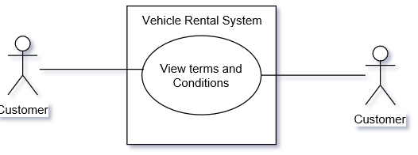

1. Choose a language

|  |  |
| --- | --- |
| Use Case Name | Choose a language |
| Scope | Under Design |
| Level | Sub function |
| Primary Actor | Customer |
| Stakeholders and Interest | Professor and Customer |
| Preconditions | Application should be up and running |
| Success Guarantee | Customer able to view the web in specified language |
| Main Success Scenario | 1. Customer chooses a language |
| Extensions | Scenario 1:  1a) Customer re-chooses the language |
| Special Requirements | Response time should be within seconds |
| Technology and Data Variations List | Browser, Database |
| Frequency of Occurrence | Could be nearly continuous |
| Miscellaneous | N/A |

Use Case Diagram: Choose a language

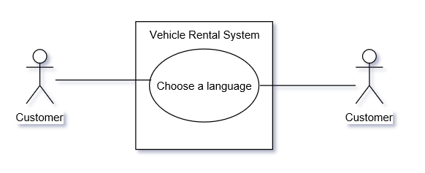

1. Rent a vehicle for long term

|  |  |
| --- | --- |
| Use Case Name | Rent a vehicle for long term |
| Scope | Under Design |
| Level | Sub function |
| Primary Actor | Customer |
| Stakeholders and Interest | Professor and Customer |
| Preconditions | Application should be up and running |
| Success Guarantee | Long term rentals |
| Main Success Scenario | 1. Customer visits the website 2. Customer chooses a vehicle 3. Customer rents for long term |
| Extensions | Scenario 1:  1a) Customer refreshes website |
| Special Requirements | Response time should be within seconds |
| Technology and Data Variations List | Browser, Database |
| Frequency of Occurrence | Could be nearly continuous |
| Miscellaneous | N/A |

Use Case Diagram: Rent a vehicle for long term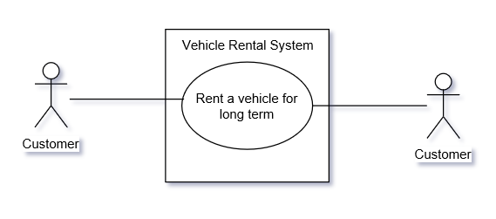

1. View reward points

|  |  |
| --- | --- |
| Use Case Name | View reward points |
| Scope | Under Design |
| Level | Sub function |
| Primary Actor | Customer |
| Stakeholders and Interest | Professor and Customer |
| Preconditions | Customer should be logged into the system |
| Success Guarantee | View reward points |
| Main Success Scenario | 1. Customer selects to view reward points |
| Extensions | Scenario 1:  1a) Customer reloads to review the reward points |
| Special Requirements | Response time should be within seconds |
| Technology and Data Variations List | Browser, Database |
| Frequency of Occurrence | Could be nearly continuous |
| Miscellaneous | N/A |

Use Case Diagram: View reward points

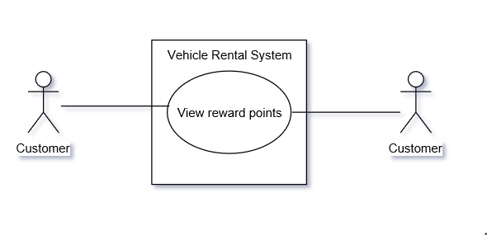

1. Rate and Review

|  |  |
| --- | --- |
| Use Case Name | Rate and Review |
| Scope | Under Design |
| Primary Actor | Customer |
| Stakeholders and Interest | Professor and Customer |
| Preconditions | Customer should complete his/her Trip |
| Success Guarantee | Ratings and Reviews are updated. |
| Main Success Scenario | 1. Customer visits the website 2. Customer enter the rating and reviews the experience 3. Ratings and Reviews are updated |
| Extensions | Scenario 1:  1a) Customer refreshes Page  Scenario 2:  2a) Customer is asked to re-enter the rating and review |
| Special Requirements | Response time should be within seconds |
| Technology and Data Variations List | Browser, Database |
| Frequency of Occurrence | Could be nearly continuous |
| Miscellaneous | NA |

Use Case Diagram: Rate and Review

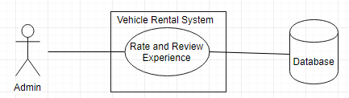

1. Choose Additional Accessories

|  |  |
| --- | --- |
| Use Case Name | Choose additional accessories |
| Scope | Under Design |
| Level | Sub Function |
| Primary Actor | Customer |
| Stakeholders and Interest | Professor, Customer |
| Preconditions | Customer needs to select a vehicle |
| Success Guarantee | List of Accessories are displayed and selected |
| Main Success Scenario | 1.Customer searches for additional accessories  2.Customer selects additional accessories |
| Extensions | Scenario 1:  1a) Customer refreshes Page |
| Special Requirements | Response time should be within seconds |
| Technology and Data Variations List | Browser, Database |
| Frequency of Occurrence | Could be nearly continuous |
| Miscellaneous | NA |

Use Case Diagram: Choose additional accessories

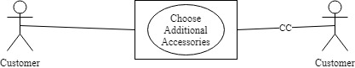

1. Pick up and Drop off Location

|  |  |
| --- | --- |
| Use Case Name | Select Pick up and Drop off location |
| Scope | Under Design |
| Level | Sub Function |
| Primary Actor | Customer |
| Stakeholders and Interest | Professor, Customer |
| Preconditions | Customer should have selected vehicle |
| Success Guarantee | Selects Customers Pick up and Drop off location |
| Main Success Scenario | 1.Customer visits the website  2.Customer select pick up and Drop off location |
| Extensions | Scenario 1:  1a) Customer Re-select pick up and drop off location |
| Special Requirements | Response time should be within seconds |
| Technology and Data Variations List | Browser, Database |
| Frequency of Occurrence | could be nearly continuous |
| Miscellaneous | NA |

Use Case Diagram: Pick up and Drop off location

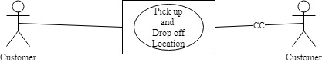

1. Access to Reports

|  |  |
| --- | --- |
| Use Case Name | Access to Reports |
| Scope | Under Design |
| Level | Sub Function |
| Primary Actor | Administrator |
| Stakeholders and Interest | Professor, Administrator |
| Preconditions | Application should be up and running |
| Success Guarantee | Reports are displayed |
| Main Success Scenario | 1.Administrator visits the website  2.Administrator selects the type of report  3.The Reports are displayed |
| Extensions | Scenario 1:  1a) Administrator refreshes Page  2a) Administrator Re-selects the type of reports |
| Special Requirements | Response time should be within seconds |
| Technology and Data Variations List | Browser, Database |
| Frequency of Occurrence | could be nearly continuous |
| Miscellaneous | NA |

Use Case Diagram: Access to Reports

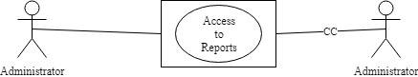

1. View Special Rates

|  |  |
| --- | --- |
| Use Case Name | View Special rates |
| Scope | Under Design |
| Level | Sub Function |
| Primary Actor | Customers |
| Stakeholders and Interest | Professor, Customer |
| Preconditions | Application should be up and running |
| Success Guarantee | All the special rates are displayed |
| Main Success Scenario | 1.Customer visits the website  2.Customer views special rates |
| Extensions | Scenario 1:  1a) Customer refreshes Page |
| Special Requirements | Response time should be within seconds |
| Technology and Data Variations List | Browser, Database |
| Frequency of Occurrence | 4 hits per second |
| Miscellaneous | NA |

Use Case Diagram: View special rates

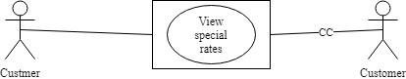

1. Manage Memberships

|  |  |
| --- | --- |
| Use Case Name | Manage Memberships |
| Scope | Under Design |
| Level | Sub Function |
| Primary Actor | Administrator, Customer |
| Stakeholders and Interest | Professor, Customer |
| Preconditions | Application should be up and running |
| Success Guarantee | Administrator assigns Customers with Memberships |
| Main Success Scenario | 1.Admin visits the website  2.Admin selects Customer to assign membership  3. Customers are assigned Membership |
| Extensions | Scenario 1:  1a) Administrator refreshes Page  2a) Administrator reassigns memberships |
| Special Requirements | Response time should be within seconds |
| Technology and Data Variations List | Browser, Database |
| Frequency of Occurrence | could be nearly continuous |
| Miscellaneous | NA |

Use Case Diagram: Manage Memberships



1. Access to Driving Records

|  |  |
| --- | --- |
| Use Case Name | Access to Driving Records |
| Scope | Under Design |
| Level | Sub Function |
| Primary Actor | Administrator |
| Stakeholders and Interest | Professor, Customer |
| Preconditions | Customer should have booked a vehicle |
| Success Guarantee | Driver’s Previous Records are displayed |
| Main Success Scenario | 1.Administrator visits the website  2.Administrator access the Driver’s Records  3.Adminitrattor allows customer to book the vehicle |
| Extensions | Scenario 1:  1a) If there are any red flags in the in driver’s records, the booking is cancelled |
| Special Requirements | Response time should be within seconds |
| Technology and Data Variations List | Browser, Database |
| Frequency of Occurrence | could be nearly continuous |
| Miscellaneous | NA |

Use Case Diagram: Access Driver’s previous Records

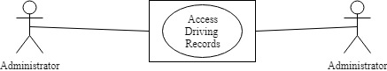

1. Redeem Reward Points

|  |  |
| --- | --- |
| Use Case Name | Redeem Rewards Points |
| Scope | Under Design |
| Level | Sub Function |
| Primary Actor | Customers |
| Stakeholders and Interest | Professor, Customer |
| Preconditions | Customer must be logged into the system |
| Success Guarantee | Customers Reward Points are Redeemed |
| Main Success Scenario | 1.Customer selects redeem reward points  2.Customer Redeems Reward Points for merchandize  3.The Rewards points are deducted from account |
| Extensions | Scenario 1:  1a) Customer refreshes Page  3a) If Redeeming points is unsuccessful, points are returned to the account |
| Special Requirements | Response time should be within seconds |
| Technology and Data Variations List | Browser, Database |
| Frequency of Occurrence | could be nearly continuous |
| Miscellaneous | NA |

Use Case Diagram: Redeem reward Points

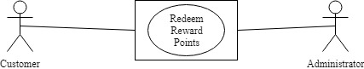

1. Navigate Pick Up Location

|  |  |
| --- | --- |
| Use Case Name | Navigate Pick Up Location |
| Scope | Under Design |
| Level | Sub Function |
| Primary Actor | Customers |
| Stakeholders and Interest | Professor, Customer |
| Preconditions | Customer has completed the car booking |
| Success Guarantee | Customer has navigated his location using map |
| Main Success Scenario | 1.Customer Navigates Pick Up Location using maps |
| Extensions | Scenario 1:  1a) Customer reloads the maps |
| Special Requirements | Response time should be within seconds |
| Technology and Data Variations List | Browser, Database |
| Frequency of Occurrence | could be nearly continuous |
| Miscellaneous | NA |

Use Case Diagram: Navigate Pick Up location

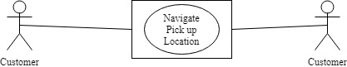

1. Access to customer benefits

|  |  |
| --- | --- |
| Use Case Name | Access to customer benefits |
| Scope | Under Design |
| Level | Sub Function |
| Primary Actor | Customers |
| Stakeholders and Interest | Professor, Customer |
| Preconditions | Customer should be registered and logged in |
| Success Guarantee | Customer gets access to customer benefits |
| Main Success Scenario | 1.Customer visits the website  2.Customer selects multiple customer benefits |
| Extensions | Scenario 1:  1a) Customer refreshes Page |
| Special Requirements | Response time should be within seconds |
| Technology and Data Variations List | Browser, Database |
| Frequency of Occurrence | could be nearly continuous |
| Miscellaneous | NA |

Use Case Diagram: Access to customer benefits

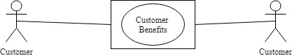

1. Provide Promotions, Membership rewards points, Family benefits

|  |  |
| --- | --- |
| Use Case Name | Provide promotions, membership rewards points, family benefits |
| Scope | Under Design |
| Level | Sub Function |
| Primary Actor | Administrator, Customer |
| Stakeholders and Interest | Professor, Customer |
| Preconditions | Customer should be registered |
| Success Guarantee | Administrator provides promotions, membership rewards points, family benefits |
| Main Success Scenario | 1.Administrator visits the website  2.Aministrator checks for membership  3.Administrator Provides promotions, membership rewards points, family benefits to Customers |
| Extensions | Scenario 1:  1a) Administrator refreshes Page  2a) If customer is not a member then page redirects to registration |
| Special Requirements | Response time should be within seconds |
| Technology and Data Variations List | Browser, Database |
| Frequency of Occurrence | could be nearly continuous |
| Miscellaneous | NA |

Use Case Diagram: Provide promotions, membership rewards points, family benefits

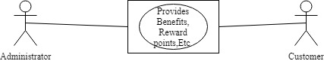

1. Administrator Should Provide Proper Encryption

|  |  |
| --- | --- |
| Use Case Name | Encryption to Customers Credentials |
| Scope | Under Design |
| Level | Sub Function |
| Primary Actor | Administrator, Customer |
| Stakeholders and Interest | Professor, Customer |
| Preconditions | Application should be up and running |
| Success Guarantee | Customers credentials are encrypted |
| Main Success Scenario | 1.Administrator visits the website  2.Administrator encrypts Customer credentials |
| Extensions | Scenario 1:  1a) Administrator refreshes Page |
| Special Requirements | Response time should be within seconds |
| Technology and Data Variations List | Browser, Database |
| Frequency of Occurrence | could be nearly continuous |
| Miscellaneous | NA |

Use Case Diagram: Encrypt Customer Credentials

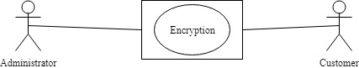

1. Choose calendar day

|  |  |
| --- | --- |
| Use Case Name | Choose Calendar Day or 24-hour day |
| Scope | Under Design |
| Level | Sub Function |
| Primary Actor | Customer |
| Stakeholders and Interest | Professor, Customer |
| Preconditions | Application should be up and running |
| Success Guarantee | Customers selects a Calendar day |
| Main Success Scenario | 1.Customer visits the website  2.Customer selects a calendar day |
| Extensions | Scenario 1:  1a) Customer refreshes Page |
| Special Requirements | Response time should be within seconds |
| Technology and Data Variations List | Browser, Database |
| Frequency of Occurrence | could be nearly continuous |
| Miscellaneous | NA |

Use Case Diagram: Calendar Day or 24 hour day

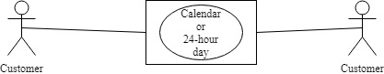

1. Customize Payments

|  |  |
| --- | --- |
| Use Case Name | Customize Payments |
| Scope | Under Design |
| Level | Sub Function |
| Primary Actor | Customer |
| Stakeholders and Interest | Professor, Customer |
| Preconditions | Customer should select a Vehicle |
| Success Guarantee | Customers customizes payments |
| Main Success Scenario | 1.Customer selects onetime payment or instalments  2.Booking is confirmed |
| Extensions | Scenario 1:  2a) Customer re-selects payments |
| Special Requirements | Response time should be within seconds |
| Technology and Data Variations List | Browser, Database |
| Frequency of Occurrence | could be nearly continuous |
| Miscellaneous | NA |

Use Case Diagram: Customize payments

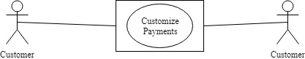

1. Payment through PayPal

|  |  |
| --- | --- |
| Use Case Name | Payment through PayPal |
| Scope | Under Design |
| Level | Sub Function |
| Primary Actor | Customer |
| Stakeholders and Interest | Professor, Customer |
| Preconditions | Customer has selected a vehicle |
| Success Guarantee | Customers pays through PayPal |
| Main Success Scenario | 1.Customer selects PayPal as payment option  2.Customer pays using PayPal  3. PayPal will authorize payment |
| Extensions | Scenario 1:  1a) Customer refreshes Page  2a) Customer selects other payment method |
| Special Requirements | Response time should be within seconds |
| Technology and Data Variations List | Browser, Database |
| Frequency of Occurrence | could be nearly continuous |
| Miscellaneous | NA |

Use Case Diagram: Payment using PayPal

